Siege Testing: The top is siege testing with all the changes from project 3, and the bottom is project 2. Surprisingly, the number of transactions was higher for the SQL. no caching approach. However, the throughput was similar, and more data was actually transferred with the project three implementation.

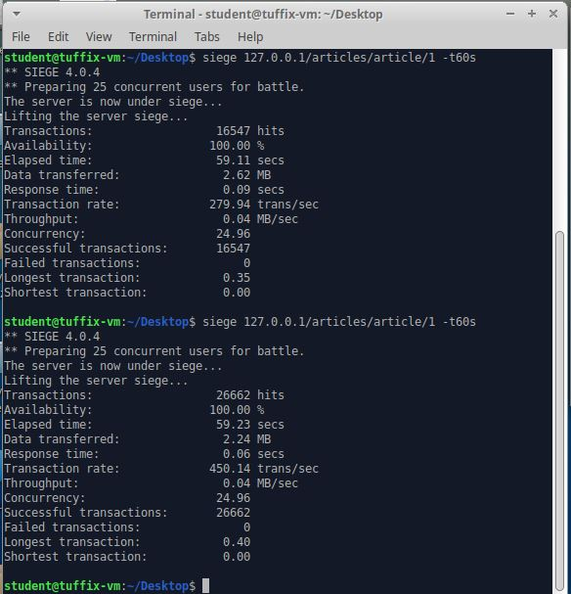

Top is project3, and bottom is project2.